Project Report for Python ATM

By

Tayler Cooper

Troy Peterson

George Moore

Kollier Martin

# Requirements / User Stories

## User Stories List

* As a user I would like to be able to login and view my balance so I know how to manage my money.
* As a user I would like to be able to transfer money to another account so I can have the ability to disperse money how I like.
* As a user I would like to be able to withdraw money from my account so I can readily have access to cash.
* As a user I would like to be able to deposit cash or check into my account so I do not have to go to a physical bank.
* As a user I would like to be able to temporarily block my card in order to better protect myself financially.

## User Stories

### Login to view balance

Author: George Moore

* Summary: The user should have the ability to login and if you their current balance.
* Description: The ATM user should be able to login via a username, password, and a pin number. This will take them to a screen to review their current balance in USD.
* Total Planned: 5  
  Planned this cycle: 5  
  Total Actual: 8  
  Actual this cycle: 8
* Relative priority: High
* Coder/s: Tayler Cooper
* Tester: Kollier Martin
* Reviewer: Entire team
* Status: Collaborative development

### Transferring Money

Author: George Moore

* Summary: The user should have the ability to transfer (or receive) money to another account.
* Description: The ATM user should be able to transfer money to another account or receive money. This will be done by having the transferrer enter the account number/username along with an amount to be transferred. The receiver will not have to do anything.
* Total Planned: 6  
  Planned this cycle: 6  
  Total Actual: 8  
  Actual this cycle: 8
* Relative priority: High
* Coder/s: Tayler Cooper
* Tester: Kollier Martin
* Reviewer: Entire team
* Status: Collaborative development

### Withdrawing Money

Author: George Moore

* Summary: The user should have the ability to withdraw money from their account.
* Description: The ATM user should be able to withdraw money. This will be done by having the user enter the amount to be transferred. It will deducted from their total balance. If there are insufficient funds, then an error message will appear.
* Total Planned: 4  
  Planned this cycle: 4  
  Total Actual: 8  
  Actual this cycle: 8
* Relative priority: High
* Coder/s: Tayler Cooper/Troy Peterson
* Tester: Kollier Martin
* Reviewer: Entire team
* Status: Collaborative development

### Depositing Money

Author: George Moore

* Summary: The user should have the ability to deposit money into their account.
* Description: The ATM user should be able to deposit money. This will be done by having the user enter the amount to be deposited. It will be added to their total balance.
* Total Planned: 4  
  Planned this cycle: 4  
  Total Actual: 8  
  Actual this cycle: 8
* Relative priority: High
* Coder/s: Tayler Cooper/Troy Peterson
* Tester: Kollier Martin
* Reviewer: Entire team
* Status: Collaborative development

### Blocking ATM Card

Author: George Moore

* Summary: The user should have the ability to block the use of their ATM card.
* Description: The ATM user should be able to block the use of their ATM card. This will be done by having the user select the account to be blocked. It can be unblocked at anytime by the user.
* Total Planned: 3  
  Planned this cycle: 3  
  Total Actual: 6  
  Actual this cycle: 6
* Relative priority: Medium
* Coder/s: Tayler Cooper/Troy Peterson
* Tester: Kollier Martin
* Reviewer: Entire team
* Status: Collaborative development

# Design Documentation

Use case UML diagram:

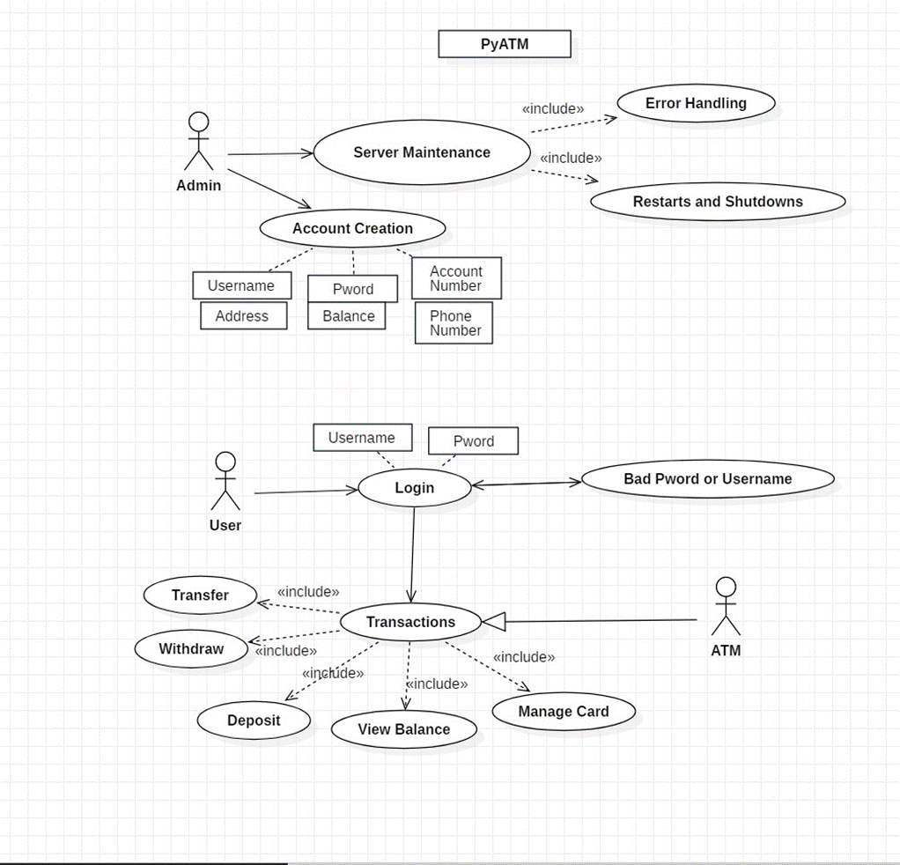

**Project code architecture:**

* PyATM: Holds all Python code
* PyATMDjango: Stores assets, includes templates(HTML), and Database(SQL)

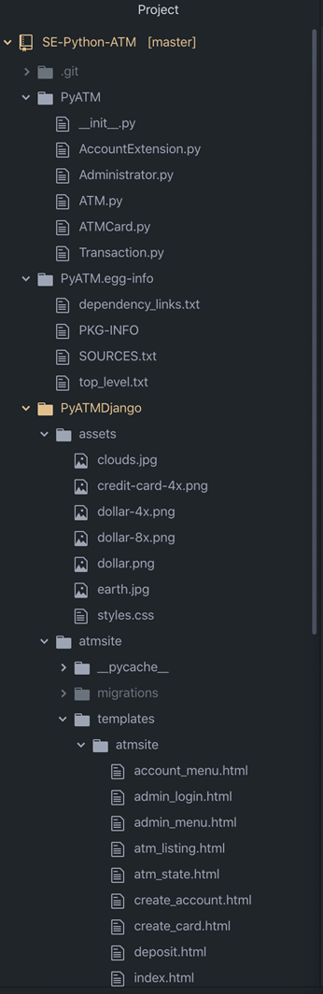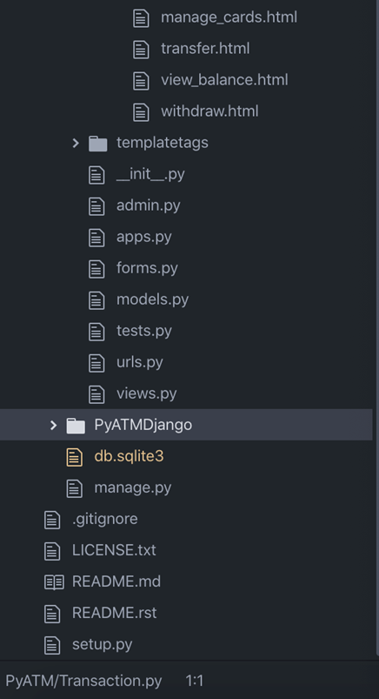

**Structure and implementation overview:**

* Views are written in python, and are functions run when certain URLs are accessed. Views calculate any values that need to be passed on to the html rendering, e.g., who is currently logged in; what is their balance.
* In HTML forms, information is sent to a “processing” URL, which doesn’t have an associated html, but instead runs the corresponding view, which grabs the information from the request using POST and modifies related database objects, which are saved to the sqlite3 database.
* After processing is performed, the URL redirects to a “presentation” URL that displays the menu.

**Simple abstraction of code structure:**

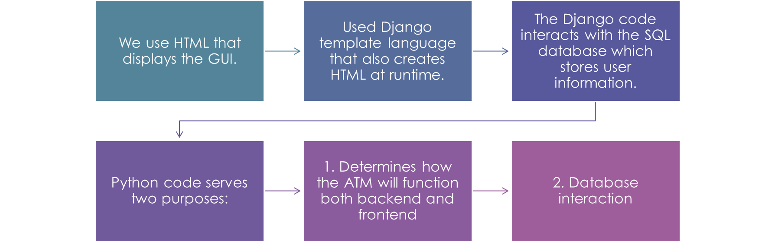

**Dependencies:**

* Django using Python and HTML/CSS.

**Interface:**

* The interface is designed to look like a hybrid between an ATM and a banking site.

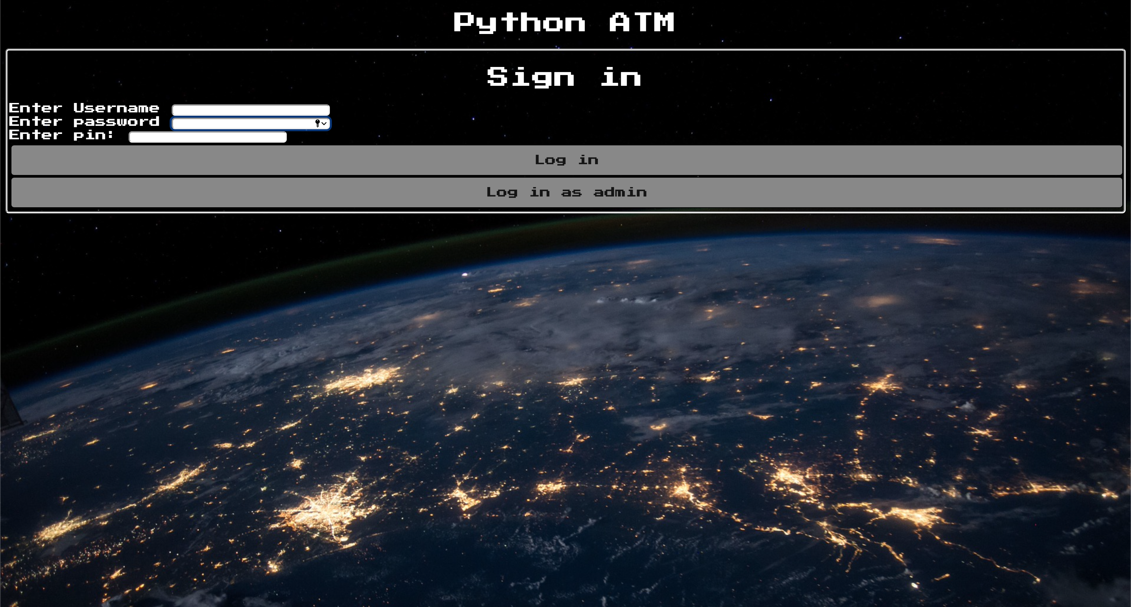

# Management Plan

ClickUp was used for our Agile development and Git/GitHub for version control.

## Development Schedule

ClickUP: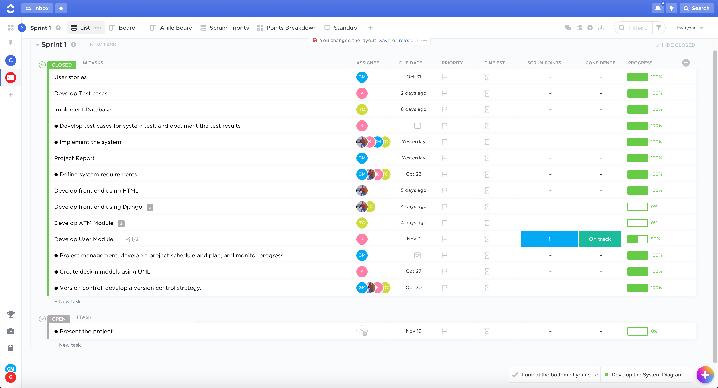

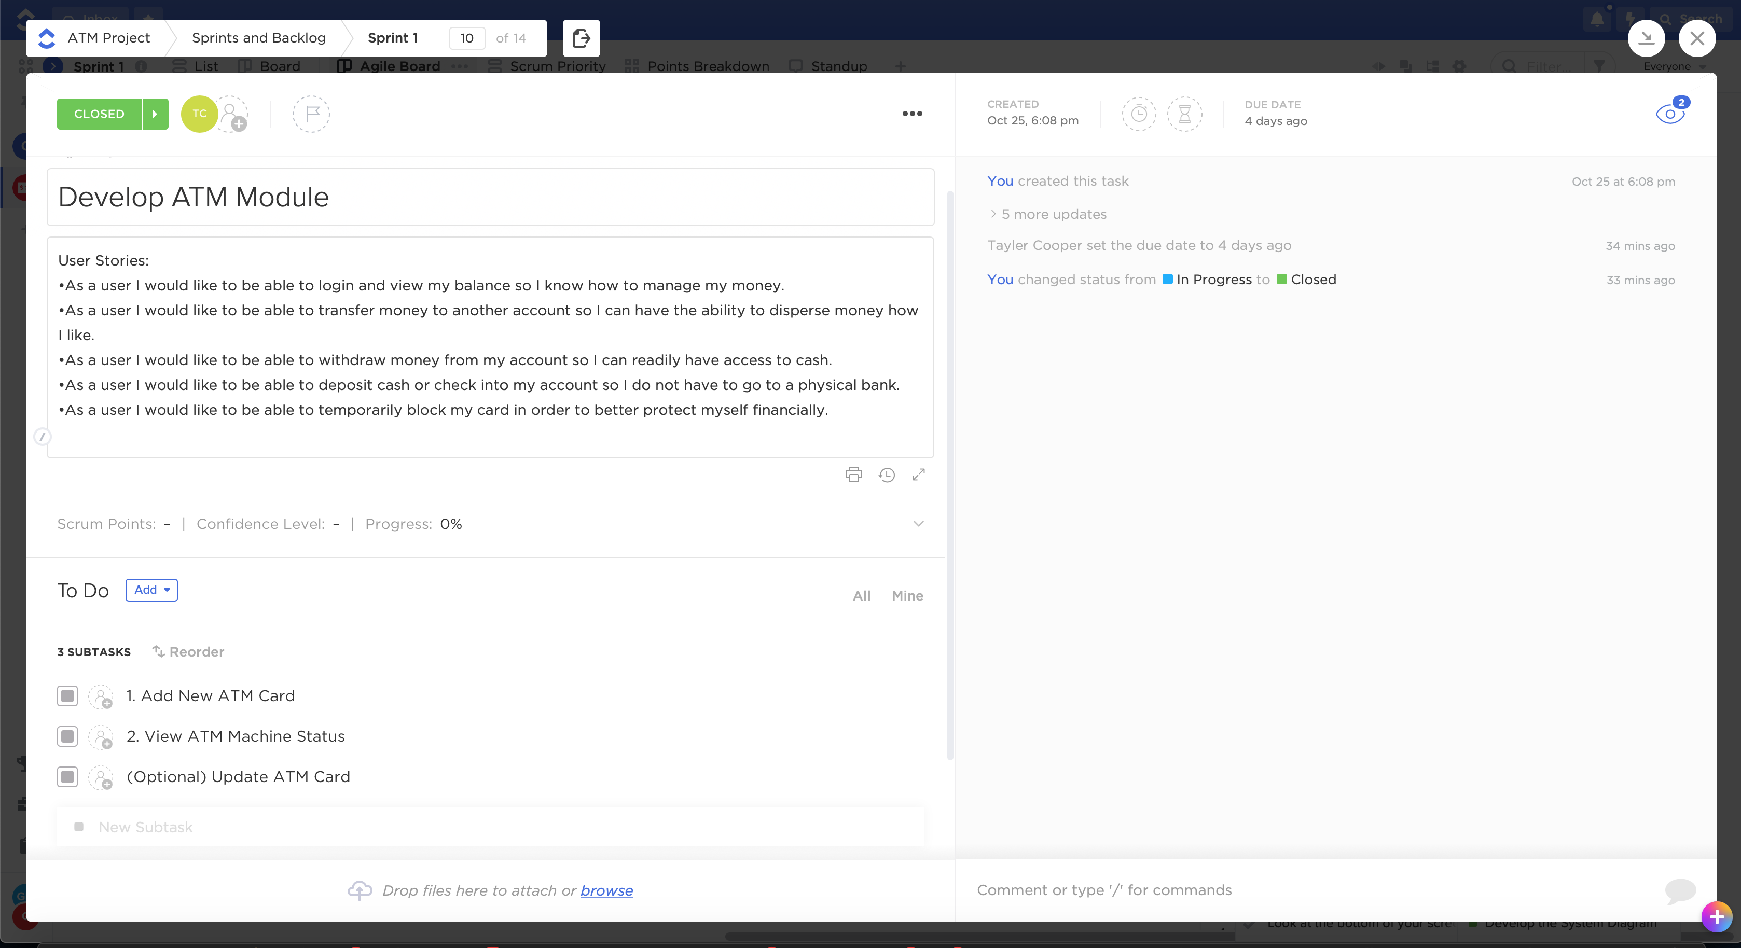

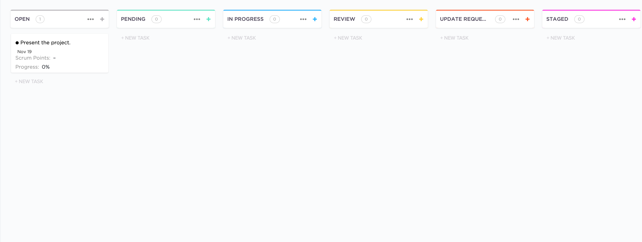

GitHub:

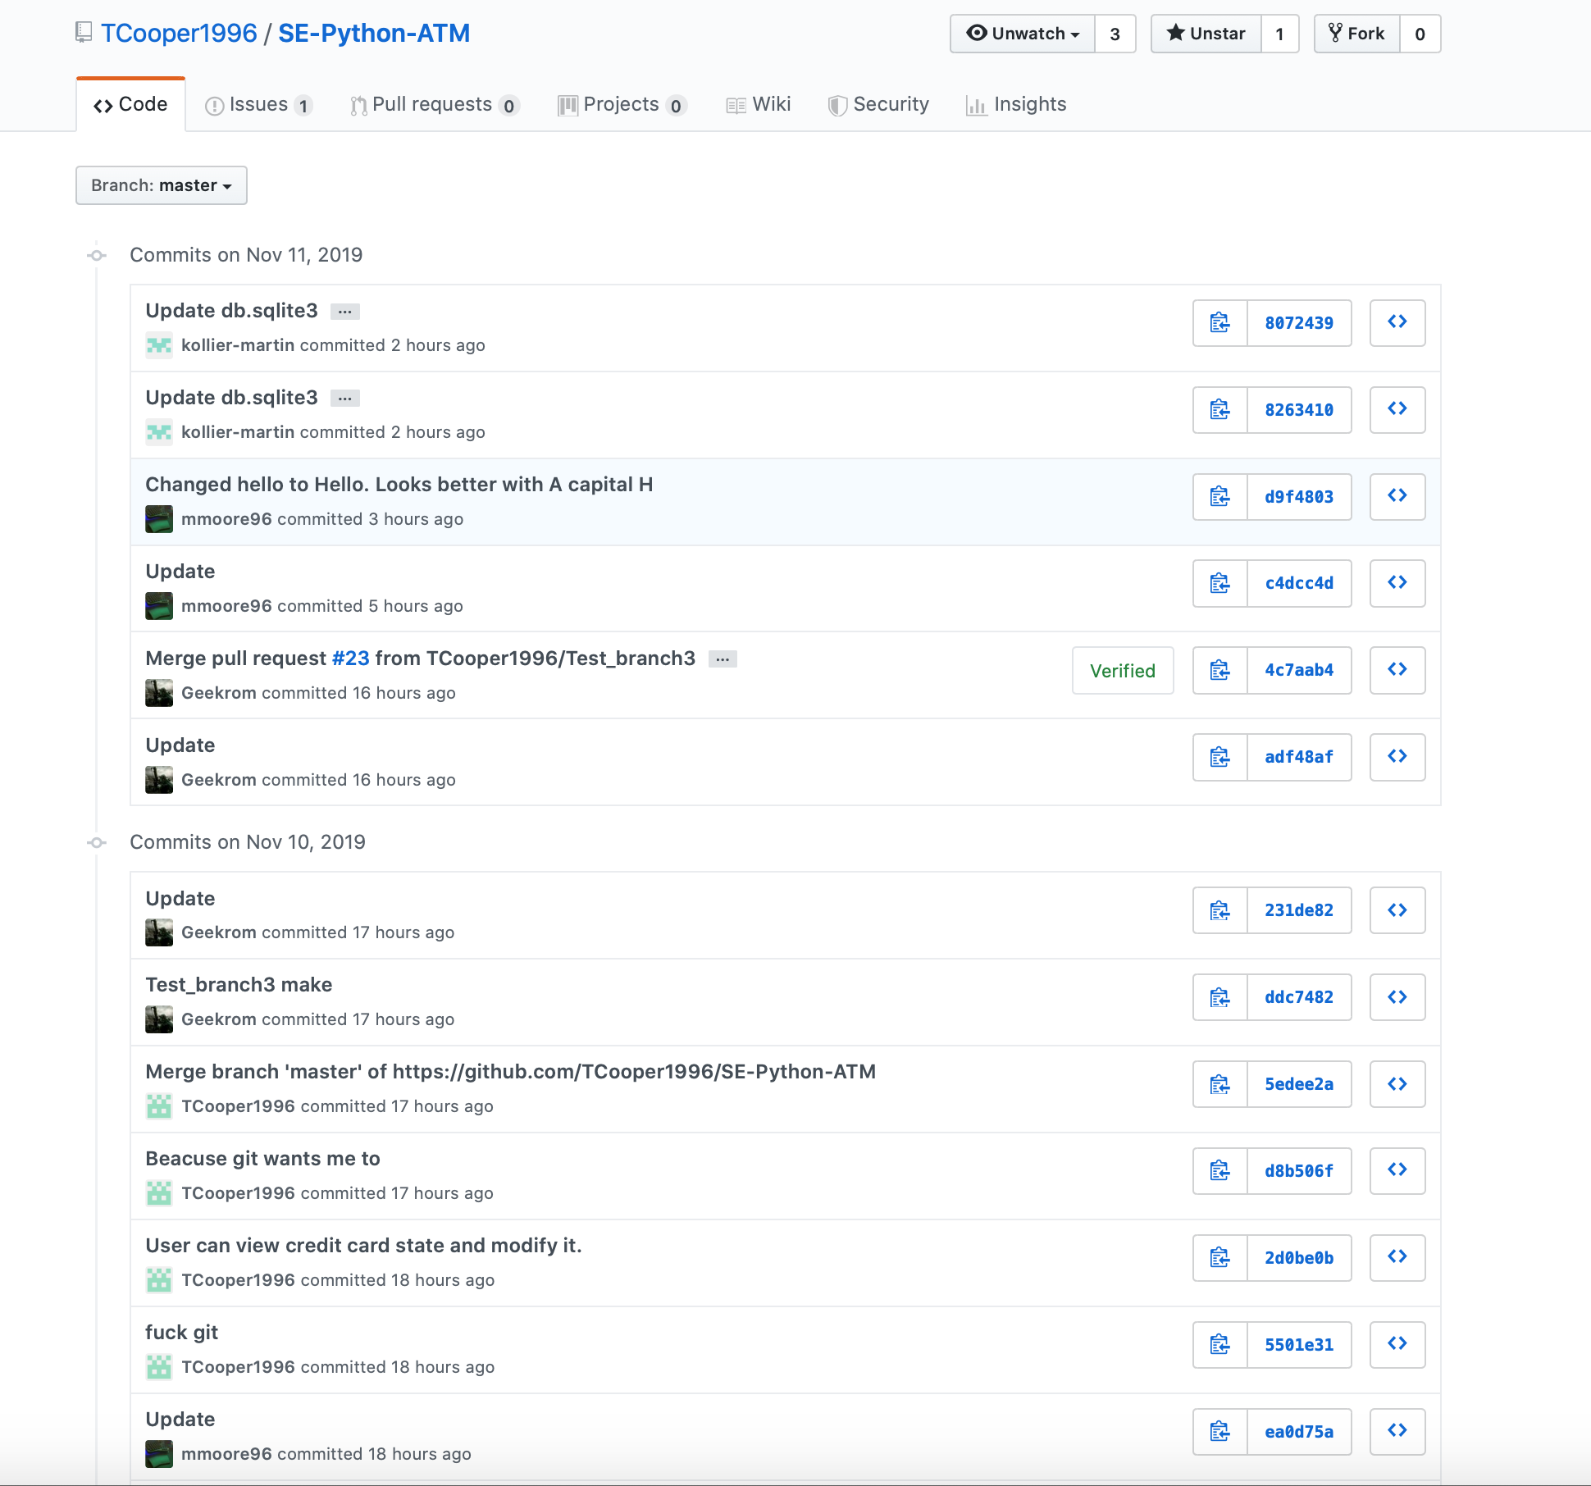

# Test

## Test Cases

### Test Procedure (See PDF below)



# Screenshots

## Screenshots based on the user stories.

Overview of options of main menu:

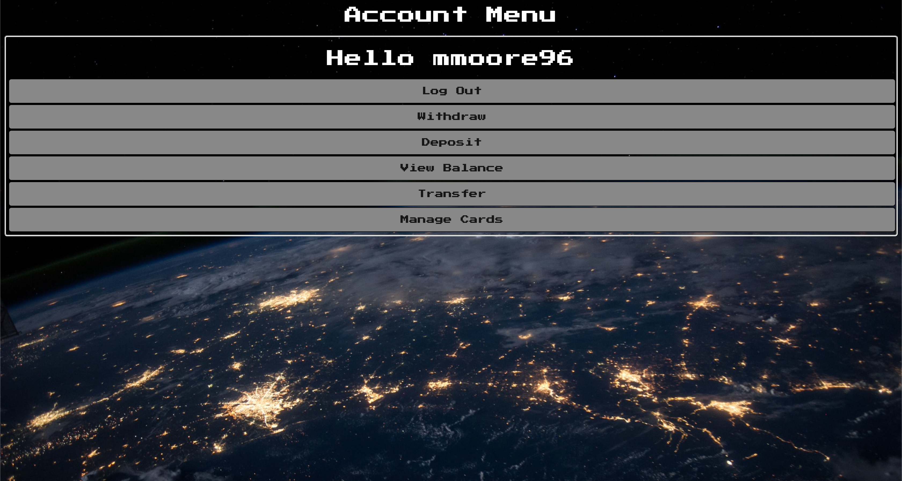

User story One:



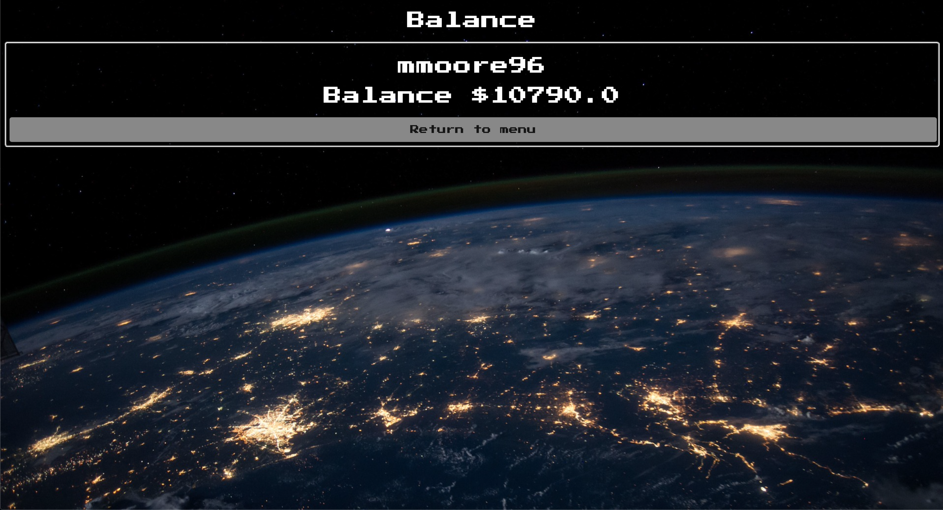

User story Two:

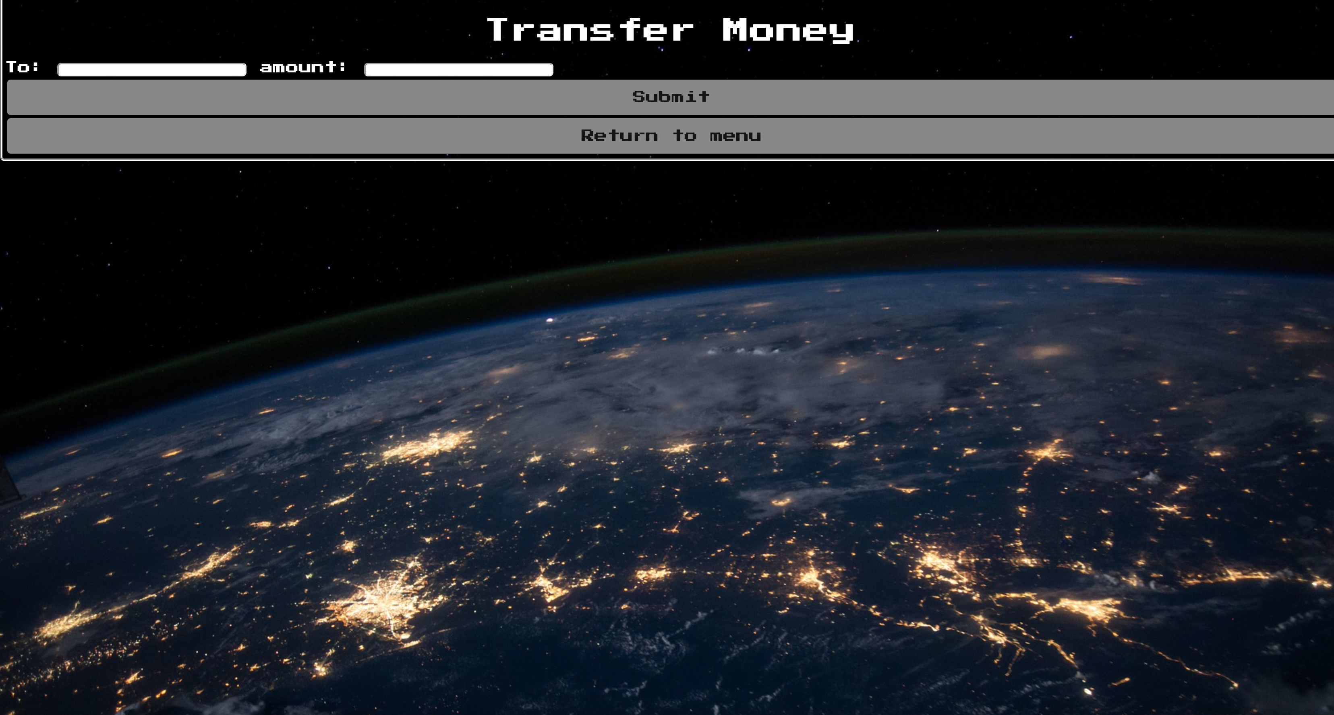

User story Three:

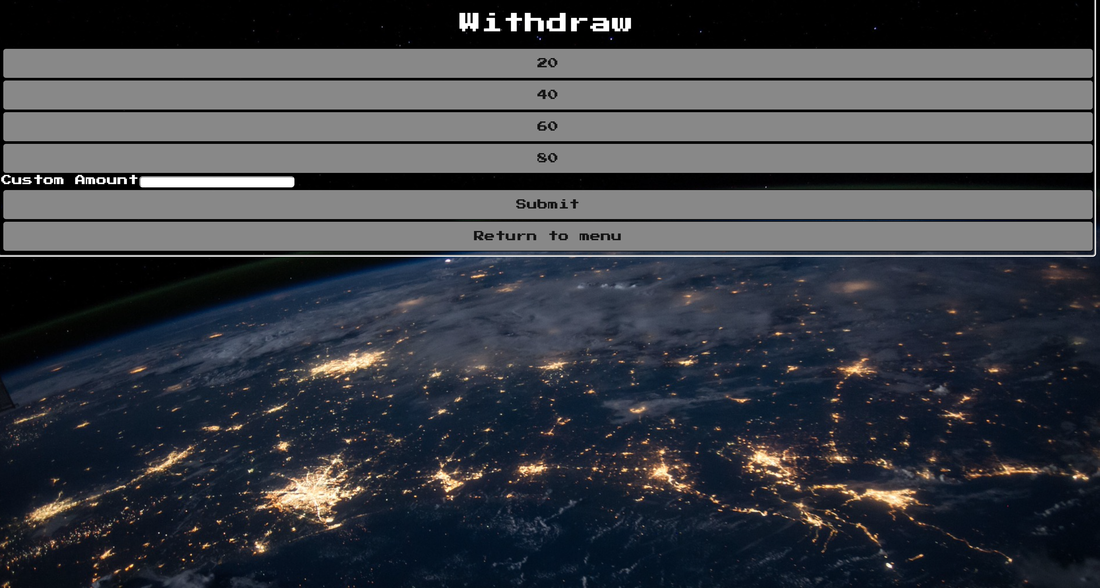

User story Four:

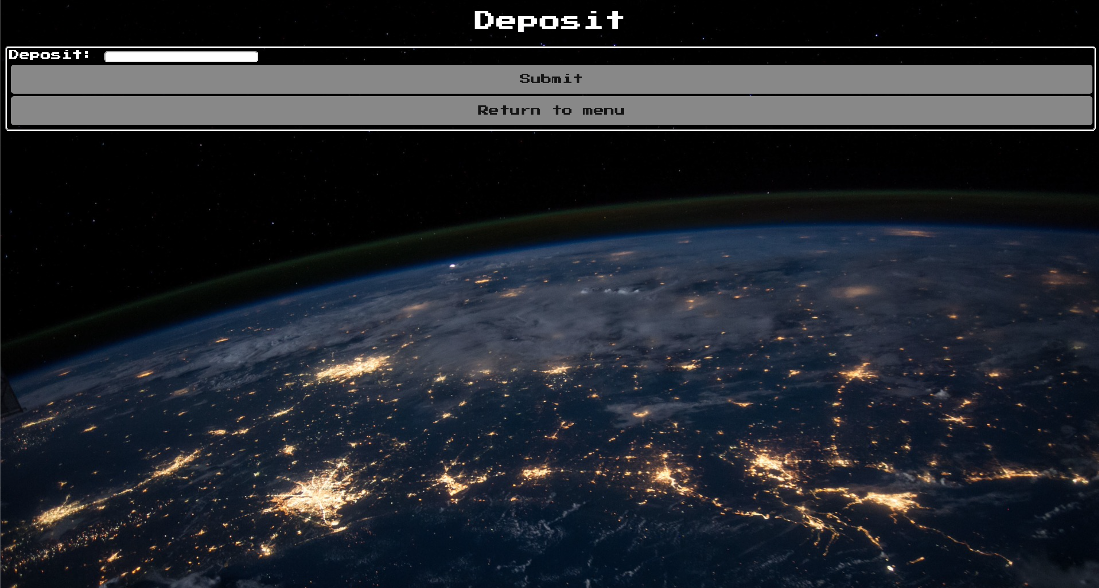

User story Five:

